CS 201 Data Structures and Algorithms
SOLUTIONS SESSIONAL 2
SPRING 2015
QUESTION 1 (Marks:2.5+2.5)
a. Write the post-order and in-order traversals for the following tree:
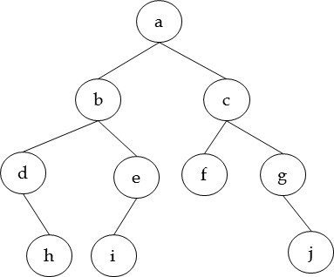
IN-ORDER:

POST-ORDER:
dhbieafcgj
hdiebfjgca
QUESTION 2 (MARKS 15)
Suppose we use a singly linear linked list to store polynomials without sentinel nodes. The node contains the degree and coefficient of each term of the polynomial. The node and linked list class are given by:
class node  { int Degree;  int Coeff;  node *next;  friend class linkedList;  }; | class linkedList  {public:  node * addPolynomial(linkedList &poly1, linkedList &poly2);  private:  node *head;  };
For example x⁵+2x³-10 is given by (terms with zero coefficients are not stored):
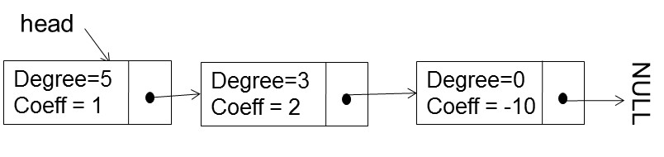
and 3x⁵-2x⁴-2x³-5x is (note the degrees are in sorted order):
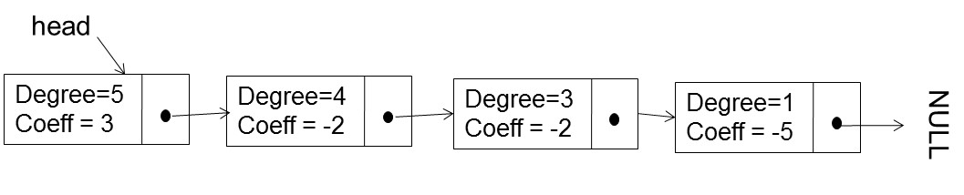
You have to implement the method addPolynomial that takes as input two lists and returns a head pointer to the third list which represents the sum of the two polynomials. The third list will use nodes from the existing lists. The new node allocation is not allowed so you are not allowed to use any ‘new’ operator. After addition only resultant polynomial is available and all other nodes are deallocated so the two input lists are completely destroyed/deallocated by this method.
For example: x⁵+2x³-10 added to 3x⁵-2x⁴-2x³-5x is: 4x⁵-2x⁴-5x-10
NOTE 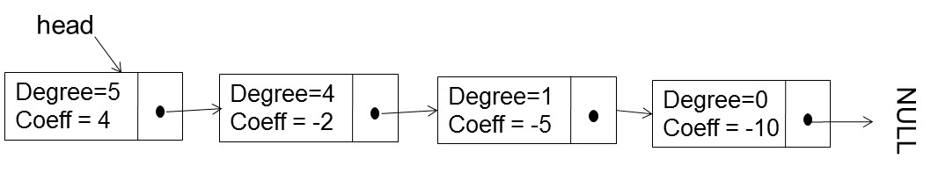
- After addition poly1.head should be NULL and poly2.head should be NULL.
- new node allocation is not allowed
- The linked list’s nodes should be sorted according to their degrees in descending order.
- Zero coefficients should not be stored.
- You are allowed to traverse the two input lists ONLY ONCE.
- The nodes of the existing lists will either be used for the new list or deleted.
- If you use any helper functions, you have to implement them too.

SOLUTION
node * addPolynomial(linkedList &poly1, linkedList &poly2)
{
node *p1 = poly1.head;
node *p2 = poly2.head;
node *tail=NULL; //to keep track of tail of sum list
linkedList sumList;
sumList.head = NULL;

while(p1 && p2)
{
if (p1->Degree > p2->Degree)
{ tail = sumList.addToEnd(p1,tail);
p1 = p1->next;
}
else if (p1->Degree < p2->Degree)
{ tail = sumList.addToEnd(p2,tail);
p2 = p2->next;
}
else if (p1->Coeff + p2->Coeff == 0)
{
//just skip these two nodes (deallocate them also)
node *temp1 = p1; //save
node *temp2 = p2;
p1 = p1->next; //skip
p2 = p2->next;
delete temp1; //deallocate
delete temp2;
}
else //coeff != 0 case
{
p1->Coeff = p1->Coeff+p2->Coeff;
tail = sumList.addToEnd(p1,tail);
//deallocate p2 and advance it also
node *temp2 = p2;
p2 = p2->next;
delete temp2;
}

}//end of while loop
//at this point either p1 is null or p2 is null or both are null (it cannot be that both are non-NULL)
if (p1)
{
sumList.addToEnd(p1,tail);
}
if (p2)
sumList.addToEnd(p2,tail);

poly1.head = nullptr;
poly2.head = nullptr;
return sumList.head;

}

//helper function
node * linkedList::addToEnd(node *toAdd,node *last)
{
if (!last)
{
head = last = toAdd;
}
else
{
last->next = toAdd;
last = toAdd;
}
return last;
}

For your solution, check it by dry run it for:
CASE 1: extreme cases when both lists are NULL OR one of them is NULL
CASE 2
poly1 (degrees): 10->9->8->2->1->NULL
poly1 (coeff): 1->3->5->1->1->NULL

poly2 (degrees): 8->3-->2-->NULL
poly2 (coeff): 2->1->-1->NULL

CASE 3
swap poly1 and poly2

QUESTION 3 (MARKS: 10)
We have to implement a stack of integers using arrays. You have to start inserting items from the middle of the array. For example if we have an array of maximum size 11:
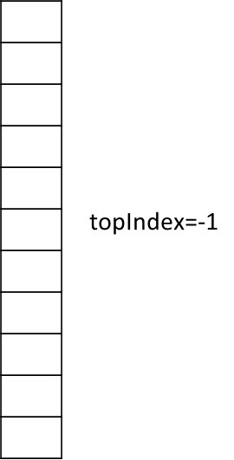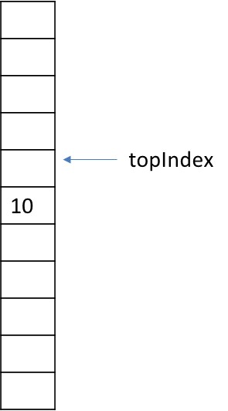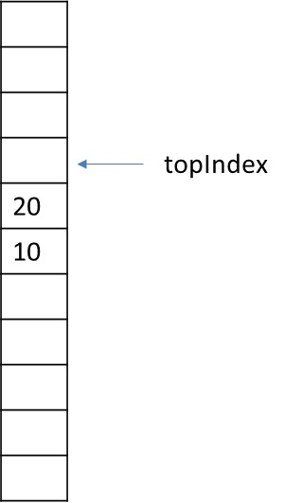
class Stack()
{
//your public methods
private:
int topIndex;
int arr[MAXSIZE];
};
Empty stack After push(10) After push(20)
Implement the IsEmpty(), IsFull(), Push() and Pop() methods for this stack class. You cannot add any data members to the stack class. The maximum items that the stack can hold is MAXSIZE.
SOLUTION
To make this work we have to make a circular buffer
bool Stack::IsEmpty()
{
return (topIndex == -1)
}

bool Stack::IsFull()
{
return (topIndex == MAXSIZE/2);
}

bool Stack::Push(int item)
{
if (IsFull)
return false;
//handle special case first
if (IsEmpty())
topIndex = MAXSIZE/2;
arr[topIndex] = item;
//rotate topIndex
topIndex = (topIndex+1)%MAXSIZE;

return true;
}

bool Stack::Pop(int &item)
{
if (isEmpty())
return false;
topIndex = (topIndex-1)%MAXSIZE;
item = arr[topIndex];
//special case…when one item is left and it is popped…see the second picture
if (topIndex == MAXSIZE/2)
topIndex = -1;

return true;
}

